Solution and Answer Guide
Camm/Cochran/Fry/Ohlmann/Anderson/Sweeney/Williams, Essentials of Modern Business Statistics w/MS Excel 9th Edition, 9780357984505; Chapter 2: Descriptive Statistics: Tabular and Graphical Displays
Table of Contents
Practice Problems 1

Practice Problems
1. Top-Rated Television Show Networks. Nielsen Media Research tracks the top-rats television shows. The following data show the television network that produced each of the 25 top-rated shows in the history of television.
CBS | CBS | NBC | FOX | CBS
CBS | NBC | NBC | NBC | ABC
ABC | NBC | ABC | ABC | NBC
CBS | NBC | CBS | ABC | NBC
NBC | CBS | CBS | ABC | CBS
a. Construct a frequency distribution, percent frequency distribution, and bar chart for the data.
b. Which networks have done the best in terms of presenting top-rated television shows? Compare the performance of ABC, CBS, and NBC.
Solution:
Step 1. As outlined in the Appendix: Getting Started with R and RStudio, change the working directory to where the file networks2012_r.csv is located
Step 2. To read the file and create a data frame, enter the following in the Console pane of RStudio:
network_df = read.csv("networks2012_r.csv")
Step 3. Enter the following to create a table of tv networks and frequencies :
table(network_df)
The following table appears in the Console:
ABC | CBS | FOX | NBC
6 | 9 | 1 | 9
Step 4. A similar function is used to construct a table of percent frequencies. Enter the following:
prop.table(table(network_df))
The following table with network frequencies appears in the Console:
ABC | CBS | FOX | NBC
0.24 | 0.36 | 0.04 | 0.36
Step 5. The following function will create a frequency chart from the table data.
barplot(table(network_df))
The following chart appears in the Plots pane of RStudio.
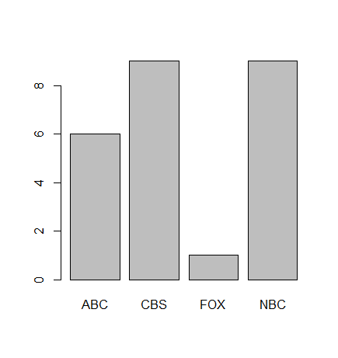
Step 6. The following command will create a frequency barplot.
barplot(prop.table(table(network_df)))
The following chart appears in the Plots pane of RStudio.
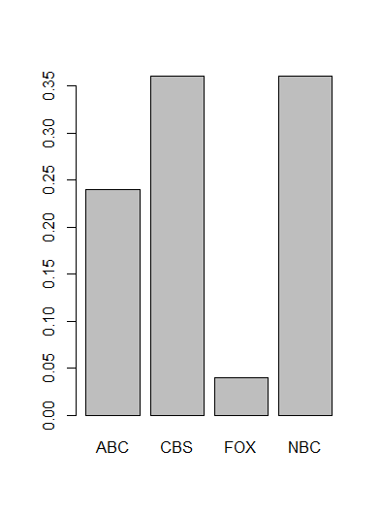
2. Low Temperatures and Snowfall. The file snow_r.csv contains temperature and snowfall data for 51 major U.S. cities over 30 years. For example, the average low temperature for Columbus, Ohio, is 44 degrees and the average annual snowfall is 27.5 inches.
a. Construct a scatter diagram with the average annual low temperature on the horizontal axis and the average annual snowfall on the vertical axis.
b. Does there appear to be any relationship between these two variables?
c. Based on the scatter diagram, comment on any data points that seem to be unusual.
Solution:
a. Construct a scatter diagram with the average annual low temperature on the horizontal axis and the average annual snowfall on the vertical axis.
Step 1. As outlined in the Appendix: Getting Started with R and RStudio, change the working directory to where the file snow_r.csv is located
Step 2. To read the file and create a data frame, enter the following in the Console pane of RStudio:
snow_df=read.csv("snow.csv")
Step3. The plot function is entered into the Console to produce the scatter plot. Enter the following:
plot(snow_df$Temp,snow_df$Snowfall,main="Scatter Plot",xlab="Snowfall", ylab="Temp",xlim=c(40,70),ylim=c(0,100))
The plot function follows this general form:
Plot(variable, main=”Title”, xlab=”x-axis label”, ylab=”y-axis label”, xlim=c(lower x-axis, upper x-axis), ylim=c(lower y-axis, upper y-axis)
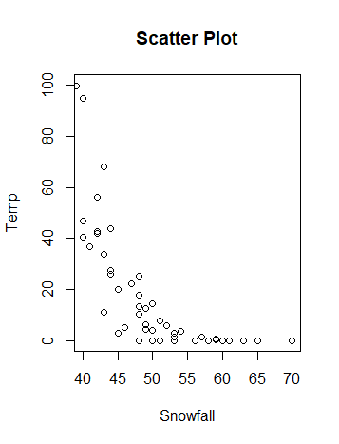
b. Does there appear to be any relationship between these two variables?
Colder average low temperature seems to lead to higher amounts of snowfall.
c. Based on the scatter diagram, comment on any data points that seem to be unusual.
Two cities have an average snowfall of nearly 100 inches of snowfall: Buffalo, New York, and Rochester, New York. Both are located near large lakes in the state.

